|  |
| --- |
| **About Us** |

|  |
| --- |
| Founded in 1990 by Christos Christoforou, the company began its journey in a small shop, dedicated to making panels and repairing motors. As the business grew, Christos’s expertise and dedication laid the foundation for a legacy of quality and innovation.  In 1999 Louis, Christos’s son, joined the company infusing it with fresh energy and ideas. As operations grew and customer needs evolved, both Christos and Louis recognized the necessity to expand. By 2010, Electrotechnic had outgrown its initial storefront. To accommodate the increasing demand for their products, they built a new, state-of-the-art factory. This facility not only enhanced their manufacturing capabilities, but also allowed them to incorporate advanced technologies, streamlining production processes.  This expansion included a new facility, housing their offices, warehouse and workspaces. Equipped with modern machines and staffed with skilled engineers and technicians, they were ready to take on new challenges.  Under Louis's guidance, Electrotechnic shifted its focus towards motor control centers, distribution board panels and building and home automation systems. This strategic move aligned perfectly with the industry's trend towards smarter, more integrated technologies, establishing Electrotechnic as an innovative force in the market.  Today, Electrotechnic thrives by continually adapting to the latest technological advancements. The company has integrated smart technology into its manufacturing processes, ensuring that its products stay at the cutting edge of innovation. With a strong focus on building and home automation, Electrotechnic has become a key provider of integrated solutions for both residential and commercial applications.  Dedicated to quality and innovation, Electrotechnic has developed smart control systems that boost energy efficiency, enhance user comfort and seamlessly fit into modern lifestyles. Their distribution boards and motor control centers are now equipped with IoT capabilities, enabling users to monitor and control their environments from anywhere. |

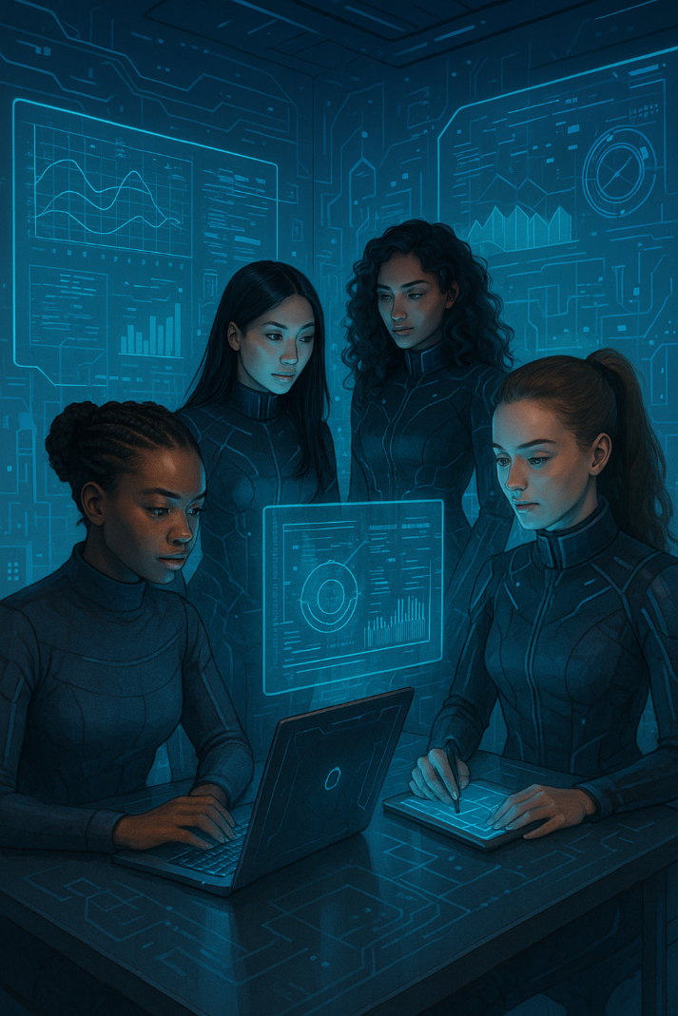

|  |
| --- |
| **What we do**  The company offers a wide range of building automation solutions designed to enhance efficiency, comfort, and ecurity in various types of buildings. Here are some of the key solutions provided:  (Carousel info) HVAC Control Systems: Automated systems to manage heating, ventilation, and air conditioning, ensuring optimal indoor climate and energy efficiency. Lighting Control Systems: Systems: Intelligent lighting solutions that adjust based on occupancy and natural light levels, reducing energy consumption and enhancing comfort. Energy Management Systems: Solutions to monitor and optimize energy usage, helping to reduce costs and environmental impact. Integrated Building Management Systems (BMS): Centralized systems that integrate various building automation functions, providing a unified platform for monitoring and control. Innovative Distribution Boards for a Residential Development: We provided high-quality distribution boards for a new residential development. These boards are designed for easy installation and maintenance, ensuring safe and reliable power distribution throughout the complex. Advanced Motor Control Centers (MCCs) for a Manufacturing Plant: We designed and manufactured custom MCCs for a major manufacturing plant. These MCCs feature state-of-the-art motor protection and control technologies, enhancing operational efficiency and reliability. |

|  |
| --- |
| **Where we work**  Our company serves a diverse range of industries with our building automation solutions. Here are some of the key sectors we cater to: Commercial Buildings: Office complexes, shopping malls, and other commercial properties benefit from our energy-efficient and secure automation systems. Residential Buildings: We provide smart home solutions for apartments, condominiums, and housing developments, enhancing comfort and security for residents. Industrial Facilities: Manufacturing plants and warehouses use our automation systems to optimize operations, improve safety, and reduce energy consumption. Healthcare: Healthcare: Hospitals and clinics rely on our solutions for maintaining optimal environmental conditions, ensuring patient comfort, and enhancing security. Educational Institutions: Schools and universities implement our systems to create efficient, safe, and comfortable learning environments. Hospitality: Hotels and resorts use our automation solutions to provide guests with a seamless and luxurious experience, from climate control to security. C:\Users\user\AppData\Local\Microsoft\Windows\INetCache\Content.Word\automation.jpgGovernment Buildings: Municipal buildings and other government facilities utilize our systems for efficient energy management and enhanced security. |

|  |
| --- |
| **What we offer**  Our company’s success is driven by several core values: Quality: We are committed to delivering products and services of the highest quality. This dedication to excellence ensures our clients receive reliable and efficient solutions. Innovation: We continuously seek to innovate and improve our offerings. By staying at the forefront of technology, we provide cutting-edge solutions that meet the evolving needs of our clients. Customer Focus: Our clients are at the heart of everything we do. We strive to understand their needs and exceed their expectations through personalized service and support. Integrity: We conduct our business with the utmost integrity, building trust with our clients, partners, and employees. Honesty and transparency are fundamental to our operations. Teamwork: Our success is built on the collaborative efforts of our dedicated team. We foster a supportive and inclusive work environment where everyone can contribute and grow. Sustainability: We are committed to sustainable practices that minimize our environmental impact. Our solutions are designed to be energy-efficient and environmentally friendly. |

